**ANDROID LAB**

**arrayadpter listview**

**<?xml version="1.0" encoding="utf-8"?>**

**<RelativeLayout xmlns:android="http://schemas.android.com/apk/res/android"**

**xmlns:app="http://schemas.android.com/apk/res-auto"**

**xmlns:tools="http://schemas.android.com/tools"**

**android:layout_width="match_parent"**

**android:layout_height="match_parent"**

**tools:context=".MainActivity" >**

**<ListView**

**android:id="@+id/MyLists"**

**android:layout_width="match_parent"**

**android:layout_height="match_parent" />**

**</RelativeLayout>**

**java**

**ackage com.example.myapplication;**

**import androidx.appcompat.app.AppCompatActivity;**

**import android.os.Bundle;**

**import android.view.View;**

**import android.widget.AdapterView;**

**import android.widget.ArrayAdapter;**

**import android.widget.ListView;**

**import android.widget.TextView;**

**import android.widget.Toast;**

**public class MainActivity extends AppCompatActivity implements AdapterView.OnItemClickListener {**

**ListView l;**

**String[] days = {"ds", "java", "c", "python"};**

**@Override**

**protected void onCreate(Bundle savedInstanceState) {**

**super.onCreate(savedInstanceState);**

**setContentView(R.layout.*activity_main*);**

**l = findViewById(R.id.*MyLists*);**

**ArrayAdapter<String> adapter = new ArrayAdapter<String>(this, androidx.appcompat.R.layout.*support_simple_spinner_dropdown_item*, days);**

**l.setAdapter(adapter);**

**l.setOnItemClickListener(this);**

**}**

**@Override**

**public void onItemClick(AdapterView<?> adapterView, View view, int position, long id) {**

**TextView temp = (TextView) view;**

**Toast.*makeText*(this,"You Clicked" +temp.getText()+ "at"+position,Toast.*LENGTH_SHORT*).show();**

**}}**

**AIM : To Develop an app that toggles images using frame layuot**

**Activity_main.xml**

<?xml version="1.0" encoding="utf-8"?>

<FrameLayout xmlns:android="http://schemas.android.com/apk/res/android"

xmlns:tools="http://schemas.android.com/tools"

android:layout_width="match_parent"

android:layout_height="match_parent"

tools:context=".MainActivity">

<ImageView

android:id="@+id/imageView"

android:layout_width="match_parent"

android:layout_height="match_parent"

android:scaleType="centerCrop"

android:src="@drawable/image1" />

</FrameLayout>

**MainActivity.java**

package com.example.abcd;  
  
import android.os.Bundle;  
import android.view.View;  
import android.widget.ImageView;  
  
import androidx.appcompat.app.AppCompatActivity;  
  
public class MainActivity extends AppCompatActivity {  
  
 private ImageView imageView;  
 private int[] images = {R.drawable.*image1*, R.drawable.*image2*, R.drawable.*image3*};  
 private int currentImageIndex = 0;  
  
 @Override  
 protected void onCreate(Bundle savedInstanceState) {  
 super.onCreate(savedInstanceState);  
 setContentView(R.layout.*activity_main*);  
  
 imageView = findViewById(R.id.*imageView*);  
 imageView.setOnClickListener(new View.OnClickListener() {  
 @Override  
 public void onClick(View v) {  
 toggleImage();  
 }  
 });  
 }  
  
 private void toggleImage() {  
 currentImageIndex = (currentImageIndex + 1) % images.length;  
 imageView.setImageResource(images[currentImageIndex]);  
 }  
}

**Output:**

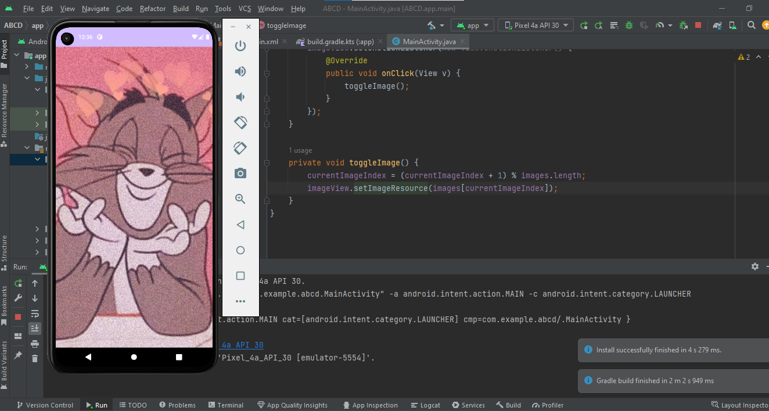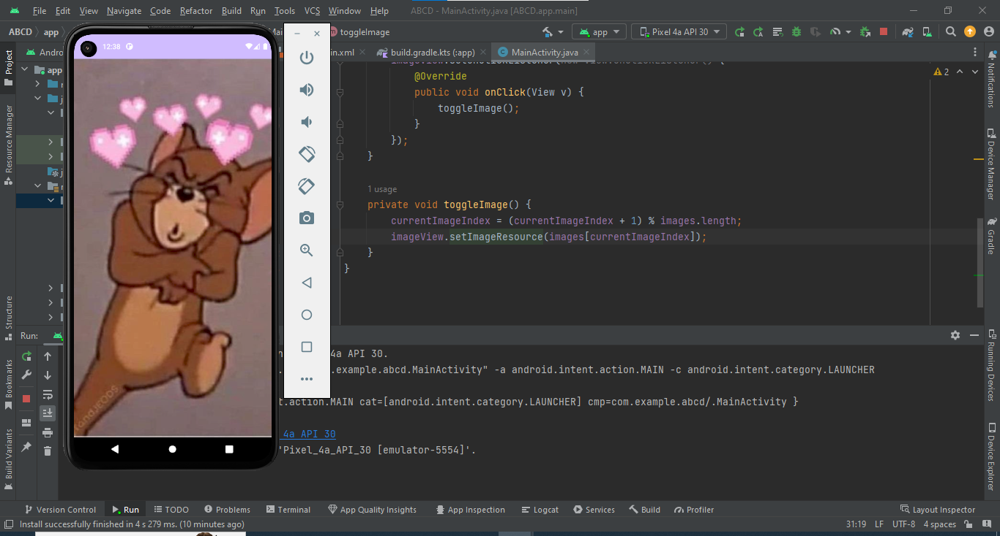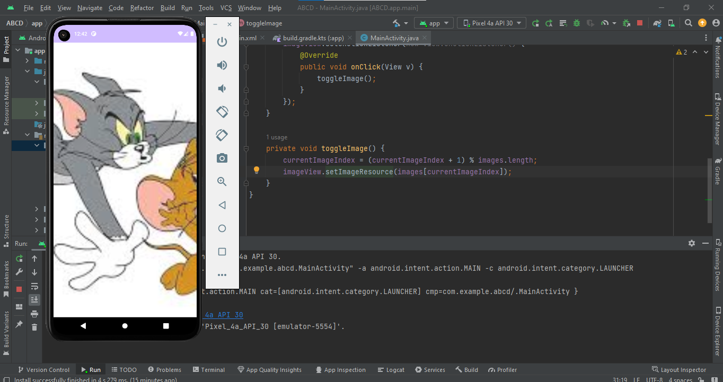

**AIM : To Develop an app that use GridView**

**Activity_main.xml**

<?xml version="1.0" encoding="utf-8"?>

<RelativeLayout

xmlns:android="http://schemas.android.com/apk/res/android"

xmlns:tools="http://schemas.android.com/tools"

android:layout_width="match_parent"

android:layout_height="match_parent"

tools:context=".MainActivity">

<ListView

android:id="@+id/simpleListView"

android:layout_width="match_parent"

android:layout_height="wrap_content" />

</RelativeLayout>

**List_item.xml**

<?xml version="1.0" encoding="utf-8"?>

<LinearLayout

xmlns:android="http://schemas.android.com/apk/res/android"

android:layout_width="match_parent"

android:layout_height="match_parent"

android:orientation="vertical">

<TextView

android:id="@+id/itemTextView"

android:layout_width="match_parent"

android:layout_height="wrap_content"

android:layout_gravity="center" />

</LinearLayout>

**MainActivity.java**

package com.example.adapter;  
  
import android.os.Bundle;  
import android.view.View;  
import android.widget.AdapterView;  
import android.widget.ArrayAdapter;  
import android.widget.ListView;  
import android.widget.Toast;  
import androidx.appcompat.app.AppCompatActivity;  
  
public class MainActivity extends AppCompatActivity {  
  
ListView simpleListView;  
  
String[] courseList = {"C-Programming", "Data Structure", "Database", "Python", "Java"};  
  
@Override  
protected void onCreate(Bundle savedInstanceState) {  
super.onCreate(savedInstanceState);  
setContentView(R.layout.*activity_main*);  
  
simpleListView = findViewById(R.id.*simpleListView*);  
  
ArrayAdapter<String> arrayAdapter = new ArrayAdapter<>(this,  
R.layout.*list_item*, R.id.*itemTextView*, courseList);  
simpleListView.setAdapter(arrayAdapter);  
  
simpleListView.setOnItemClickListener(new AdapterView.OnItemClickListener() {  
@Override  
public void onItemClick(AdapterView<?> parent, View view, int position, long id) {  
  
String selectedCourse = courseList[position];  
  
  
Toast.*makeText*(MainActivity.this, "You selected: " + selectedCourse, Toast.*LENGTH_LONG*).show();  
}  
});  
}  
}

**OUTPUT**

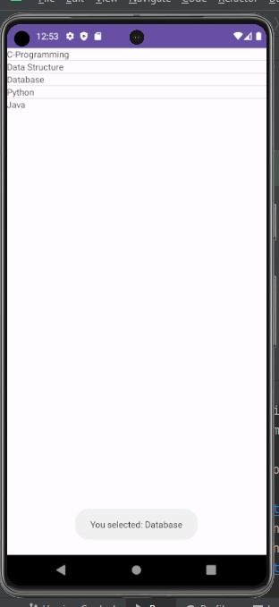

**AIM : To Develop an app that use GridView**

**Activity_main.xml**

<?xml version="1.0" encoding="utf-8"?>  
<RelativeLayout xmlns:android="http://schemas.android.com/apk/res/android"  
 xmlns:tools="http://schemas.android.com/tools"  
 android:layout_width="match_parent"  
 android:layout_height="match_parent"  
 tools:context=".MainActivity">  
  
 <GridView  
 android:id="@+id/grid"  
 android:numColumns="3"  
 android:horizontalSpacing="2dp"  
 android:verticalSpacing="2dp"  
 android:layout_width="match_parent"  
 android:layout_height="match_parent"/>  
  
</RelativeLayout>

**MainActivity.java**

package com.example.gridview;  
import android.os.Bundle;  
import android.widget.AdapterView;  
import android.widget.ArrayAdapter;  
import android.widget.GridView;  
import android.widget.Toast;  
  
import androidx.appcompat.app.AppCompatActivity;  
  
public class MainActivity extends AppCompatActivity {  
  
 String[] flowers = {"Rose", "Hibiscus", "Jasmine", "Orchid", "Iris", "Lilly", "Sunflower", "Tulip", "Lotus", "Rafflesia"};  
  
 @Override  
 protected void onCreate(Bundle savedInstanceState) {  
 super.onCreate(savedInstanceState);  
 setContentView(R.layout.*activity_main*);  
  
 GridView gridView = findViewById(R.id.*grid*);  
 ArrayAdapter<String> arrayAdapter = new ArrayAdapter<>(this, android.R.layout.*simple_list_item_1*, flowers);  
 gridView.setAdapter(arrayAdapter);  
  
 gridView.setOnItemClickListener(new AdapterView.OnItemClickListener() {  
 public void onItemClick(AdapterView<?> parent, android.view.View v, int position, long id) {  
 Toast.*makeText*(MainActivity.this, "You have selected " + flowers[position], Toast.*LENGTH_SHORT*).show();  
 }  
 });  
 }  
}

**Output:**

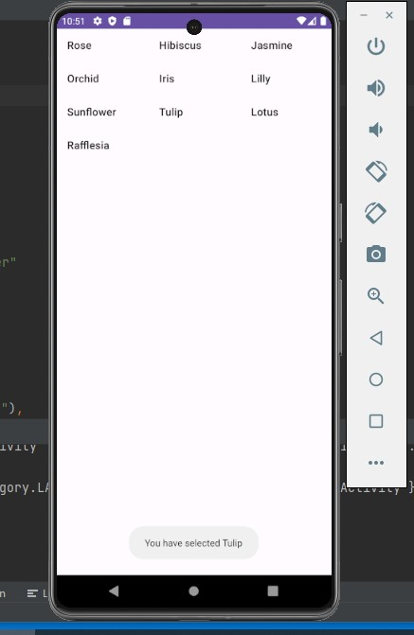

**AIM : To Develop an app that use GridView**

**Activity_main.xml**

<?xml version="1.0" encoding="utf-8"?>

<RelativeLayout xmlns:android="http://schemas.android.com/apk/res/android"

xmlns:tools="http://schemas.android.com/tools"

android:layout_width="match_parent"

android:layout_height="match_parent"

tools:context=".MainActivity">

<GridView

android:id="@+id/grid"

android:numColumns="2"

android:horizontalSpacing="2dp"

android:verticalSpacing="2dp"

android:layout_width="match_parent"

android:layout_height="match_parent"/>

</RelativeLayout>

**Grid_item.xml**

<LinearLayout xmlns:android="http://schemas.android.com/apk/res/android"

android:layout_width="match_parent"

android:layout_height="match_parent"

android:orientation="vertical"

android:padding="5dp">

<ImageView

android:id="@+id/imageView"

android:layout_width="match_parent"

android:layout_height="100dp"

android:scaleType="centerCrop" />

<TextView

android:id="@+id/textView"

android:layout_width="match_parent"

android:layout_height="wrap_content"

android:text=""

android:textAlignment="center"/>

</LinearLayout>

**MainActivity.java**

package com.example.gridview;

import android.content.Context;

import android.content.DialogInterface;

import android.os.Bundle;

import android.view.LayoutInflater;

import android.view.View;

import android.view.ViewGroup;

import android.widget.AdapterView;

import android.widget.ArrayAdapter;

import android.widget.GridView;

import android.widget.ImageView;

import android.widget.LinearLayout;

import android.widget.TextView;

import android.widget.Toast;

import androidx.appcompat.app.AlertDialog;

import androidx.appcompat.app.AppCompatActivity;

import androidx.annotation.NonNull;

import androidx.annotation.Nullable;

public class MainActivity extends AppCompatActivity {

private String[] flowers = { "Jasmine", "Lilly", "Sunflower", "Tulip"};

private int[] flowerImages = {

R.drawable.jasmine,

R.drawable.lilly,

R.drawable.sunflower,

R.drawable.tulip,

};

@Override

protected void onCreate(Bundle savedInstanceState) {

super.onCreate(savedInstanceState);

setContentView(R.layout.activity_main);

GridView gridView = findViewById(R.id.grid);

CustomAdapter customAdapter = new CustomAdapter(this, flowers, flowerImages);

gridView.setAdapter(customAdapter);

gridView.setOnItemClickListener(new AdapterView.OnItemClickListener() {

public void onItemClick(AdapterView<?> parent, View v, int position, long id) {

showAlertDialog(flowers[position], flowerImages[position]);

}

});

}

private void showAlertDialog(String flowerName, int imageResId) {

AlertDialog.Builder builder = new AlertDialog.Builder(this);

builder.setTitle("Selected Flower");

builder.setMessage("You have selected " + flowerName);

ImageView imageView = new ImageView(this);

imageView.setImageResource(imageResId);

builder.setView(imageView);

builder.setPositiveButton("OK", new DialogInterface.OnClickListener() {

@Override

public void onClick(DialogInterface dialog, int which) {

dialog.dismiss();

}

});

builder.show();

}

private static class CustomAdapter extends ArrayAdapter<String> {

private Context context;

private String[] flowers;

private int[] flowerImages;

public CustomAdapter(Context context, String[] flowers, int[] flowerImages) {

super(context, R.layout.grid_item, flowers);

this.context = context;

this.flowers = flowers;

this.flowerImages = flowerImages;

}

@NonNull

@Override

public View getView(int position, @Nullable View convertView, @NonNull ViewGroup parent) {

LayoutInflater inflater = (LayoutInflater) context.getSystemService(Context.LAYOUT_INFLATER_SERVICE);

View gridView;

if (convertView == null) {

gridView = new View(context);

gridView = inflater.inflate(R.layout.grid_item, null);

TextView textView = gridView.findViewById(R.id.textView);

textView.setText(flowers[position]);

ImageView imageView = gridView.findViewById(R.id.imageView);

imageView.setImageResource(flowerImages[position]);

} else {

gridView = convertView;

}

return gridView;

}

}

}

**Output:**

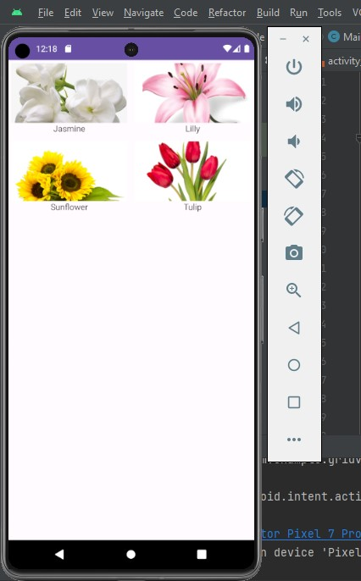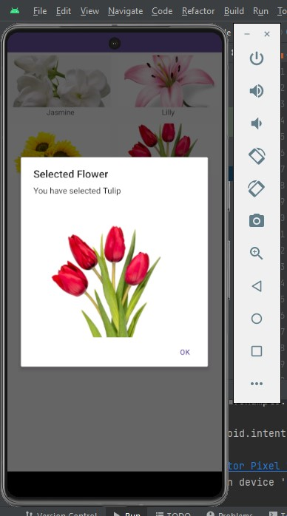

**fragments**

**xml activity**

**<?xml version="1.0" encoding="utf-8"?>**

**<FrameLayout**

**android:id="@+id/fragment_container"**

**xmlns:android="http://schemas.android.com/apk/res/android"**

**xmlns:app="http://schemas.android.com/apk/res-auto"**

**xmlns:tools="http://schemas.android.com/tools"**

**android:layout_width="match_parent"**

**android:layout_height="match_parent"**

**tools:context=".MainActivity">**

**<TextView**

**android:layout_width="wrap_content"**

**android:layout_height="wrap_content"**

**app:layout_constraintBottom_toBottomOf="parent"**

**app:layout_constraintEnd_toEndOf="parent"**

**app:layout_constraintStart_toStartOf="parent"**

**app:layout_constraintTop_toTopOf="parent" />**

**<Button**

**android:id="@+id/fragment1"**

**android:layout_width="100dp"**

**android:layout_height="50dp"**

**android:layout_marginStart="200dp"**

**android:layout_marginTop="100"**

**android:layout_marginEnd="100dp"**

**android:text="Fragment1"**

**android:textSize="10dp"**

**tools:layout_editor_absoluteX="16dp"**

**tools:layout_editor_absoluteY="16dp" />**

**<Button**

**android:id="@+id/fragment2"**

**android:layout_width="100dp"**

**android:layout_height="50dp"**

**android:layout_marginStart="200dp"**

**android:layout_marginTop="150"**

**android:layout_marginEnd="300dp"**

**android:text="Fragment2"**

**android:textSize="10dp"**

**tools:ignore="MissingConstraints"**

**tools:layout_editor_absoluteX="17dp"**

**tools:layout_editor_absoluteY="67dp" />**

**</FrameLayout>**

**first fragmenwt**

**<?xml version="1.0" encoding="utf-8"?>**

**<FrameLayout xmlns:android="http://schemas.android.com/apk/res/android"**

**xmlns:tools="http://schemas.android.com/tools"**

**android:layout_width="match_parent"**

**android:layout_height="match_parent"**

**tools:context=".firstfragment">**

**<!-- *TODO: Update blank fragment layout* -->**

**<TextView**

**android:layout_width="match_parent"**

**android:layout_height="match_parent"**

**android:text="First Fragment" />**

**</FrameLayout>**

**second fragment**

**<?xml version="1.0" encoding="utf-8"?>**

**<FrameLayout xmlns:android="http://schemas.android.com/apk/res/android"**

**xmlns:tools="http://schemas.android.com/tools"**

**android:layout_width="match_parent"**

**android:layout_height="match_parent"**

**tools:context=".secondfragment">**

**<!-- *TODO: Update blank fragment layout* -->**

**<TextView**

**android:layout_width="match_parent"**

**android:layout_height="match_parent"**

**android:text="Second fragment" />**

**</FrameLayout>**

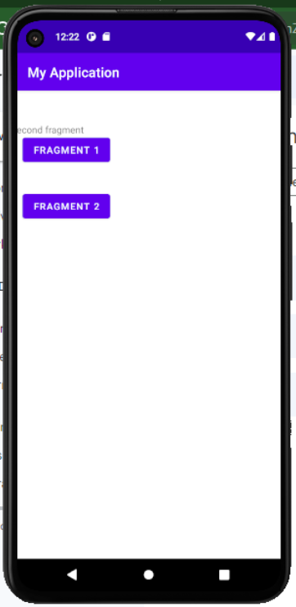

**AIM : Develop an application that implements Spinner component and perform event handling**

**Co4 :**

**Procedure :**

**Activity_main.xml**

<?xml version="1.0" encoding="utf-8"?>

<LinearLayout

xmlns:android="http://schemas.android.com/apk/res/android"

xmlns:tools="http://schemas.android.com/tools"

android:layout_width="match_parent"

android:layout_height="match_parent"

android:orientation="vertical"

android:padding="16dp"

tools:context=".MainActivity">

<Spinner

android:id="@+id/coursesSpinner"

android:layout_width="match_parent"

android:layout_height="wrap_content"

android:layout_marginTop="10dp"

android:layout_marginBottom="10dp" />

</LinearLayout>

**ACTIVITYmain.java**

package com.example.spinnerapp;

import android.os.Bundle;

import android.view.View;

import android.widget.AdapterView;

import android.widget.ArrayAdapter;

import android.widget.Spinner;

import android.widget.Toast;

import androidx.appcompat.app.AppCompatActivity;

public class MainActivity extends AppCompatActivity implements AdapterView.OnItemSelectedListener {

String[] courses = {"C", "Data structures", "DSA with java", "OS"};

@Override

protected void onCreate(Bundle savedInstanceState) {

super.onCreate(savedInstanceState);

setContentView(R.layout.activity_main);

Spinner coursesSpinner = findViewById(R.id.coursesSpinner);

coursesSpinner.setOnItemSelectedListener(this);

ArrayAdapter<String> adapter = new ArrayAdapter<>(

this,

android.R.layout.simple_spinner_item,

courses

);

adapter.setDropDownViewResource(android.R.layout.simple_spinner_dropdown_item);

coursesSpinner.setAdapter(adapter);

}

@Override

public void onItemSelected(AdapterView<?> parent, View view, int position, long id) {

Toast.makeText(getApplicationContext(), courses[position], Toast.LENGTH_LONG).show();

}

@Override

public void onNothingSelected(AdapterView<?> parent) {

}}

**OUTPUT :**

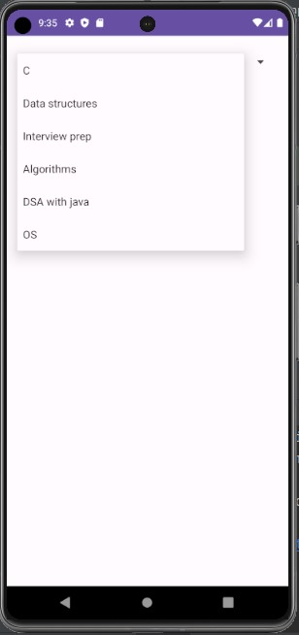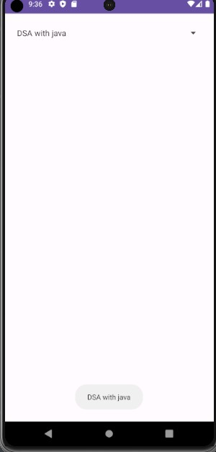

**AIM : Implement CRUD operation**

**CO5:**

**Procedures :**

**Activity_main.XML**

<?xml version="1.0" encoding="utf-8"?>

<LinearLayout xmlns:android="http://schemas.android.com/apk/res/android"

xmlns:tools="http://schemas.android.com/tools"

android:layout_width="match_parent"

android:layout_height="match_parent"

android:orientation="vertical"

android:padding="16dp"

tools:context=".MainActivity">

<EditText

android:id="@+id/ed1"

android:layout_width="match_parent"

android:layout_height="wrap_content"

android:layout_marginBottom="16dp"

android:hint="rollno" />

<EditText

android:id="@+id/ed2"

android:layout_width="match_parent"

android:layout_height="wrap_content"

android:hint="Name"

android:layout_marginBottom="16dp"/>

<EditText

android:id="@+id/ed3"

android:layout_width="match_parent"

android:layout_height="wrap_content"

android:hint="Address"

android:layout_marginBottom="16dp"/>

<Button

android:id="@+id/btnInsert"

android:layout_width="match_parent"

android:layout_height="wrap_content"

android:text="Insert"

android:onClick="insertDB"

android:layout_marginBottom="16dp"/>

<Button

android:id="@+id/btnUpdate"

android:layout_width="match_parent"

android:layout_height="wrap_content"

android:text="Update"

android:onClick="updateDB"

android:layout_marginBottom="16dp"/>

<Button

android:id="@+id/btnDelete"

android:layout_width="match_parent"

android:layout_height="wrap_content"

android:text="Delete"

android:onClick="deleteDB"

android:layout_marginBottom="16dp"/>

<Button

android:id="@+id/btnRead"

android:layout_width="match_parent"

android:layout_height="wrap_content"

android:text="Read"

android:onClick="readDB"/>

</LinearLayout>

**DbHelper.java**

package com.example.crudapp;

import android.content.Context;

import android.database.sqlite.SQLiteDatabase;

import android.database.sqlite.SQLiteOpenHelper;

import androidx.annotation.Nullable;

public class DbHelper extends SQLiteOpenHelper {

public DbHelper(@Nullable Context context) {

super(context, "student.db", null, 1);

}

@Override

public void onCreate(SQLiteDatabase sqLiteDatabase) {

sqLiteDatabase.execSQL("create table stud_tbl(rollno int ,name varchar(10),address varchar(25))");

}

@Override

public void onUpgrade(SQLiteDatabase sqLiteDatabase, int i, int i1) {

}

}

**MainActivity.java**

package com.example.crudapp;

import androidx.appcompat.app.AppCompatActivity;

import android.annotation.SuppressLint;

import android.content.ContentValues;

import android.database.Cursor;

import android.database.sqlite.SQLiteDatabase;

import android.os.Bundle;

import android.view.View;

import android.widget.EditText;

import android.widget.Toast;

public class MainActivity extends AppCompatActivity {

EditText e1,e2,e3;

DbHelper helper= new DbHelper(this);

SQLiteDatabase db;

@SuppressLint("MissingInflatedId")

@Override

protected void onCreate(Bundle savedInstanceState) {

super.onCreate(savedInstanceState);

setContentView(R.layout.activity_main);

//important steps

// DbHelper helper= new DbHelper(this);

// SQLiteDatabase db;

db=helper.getReadableDatabase();

db=helper.getWritableDatabase();

//important steps

e1=findViewById(R.id.ed1);

e2=findViewById(R.id.ed2);

e3=findViewById(R.id.ed3);

}

public void insertDB(View view) {

String r=e1.getText().toString();

String n=e2.getText().toString();

String a=e3.getText().toString();

ContentValues data=new ContentValues();

data.put("rollno",r);

data.put("name",n);

data.put("address",a);

db.insert("stud_tbl",null,data);

Toast.makeText(this, "Data Inserted", Toast.LENGTH_LONG).show();

}

public void updateDB(View view) {

String r=e1.getText().toString();

String n=e2.getText().toString();

String a=e3.getText().toString();

ContentValues data=new ContentValues();

data.put("rollno",r);

data.put("name",n);

data.put("address",a);

db.update("stud_tbl",data,"rollno="+r,null);

Toast.makeText(this, "Data Updated...", Toast.LENGTH_LONG).show();

}

public void deleteDB(View view) {

String r=e1.getText().toString();

String n=e2.getText().toString();

String a=e3.getText().toString();

db.delete("stud_tbl","rollno="+r,null);

Toast.makeText(this, "Data Deleted Succesfully..", Toast.LENGTH_LONG).show();

}

public void readDB(View view) {

StringBuffer buffer=new StringBuffer();

Cursor c =db.rawQuery("select * from stud_tbl",null);

while (c.moveToNext()){

buffer.append("ID:"+c.getString(0)+"\t");

buffer.append("NAME:"+c.getString(1)+"\t");

buffer.append("Address:"+c.getString(2)+"\t");

}

Toast.makeText(this,buffer.toString(),Toast.LENGTH_LONG).show();

}

}

**OUTPUT :**

**DBiNSERT:**

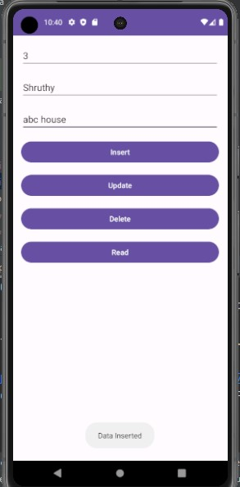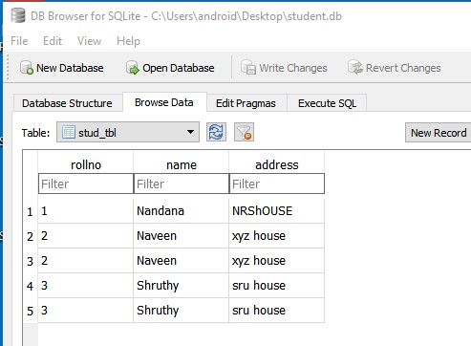

**DbUpdate:**

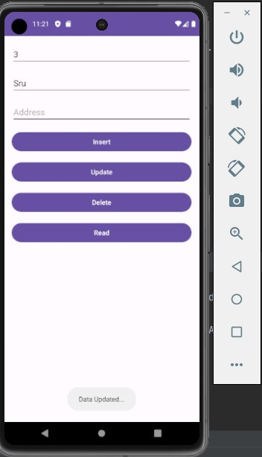 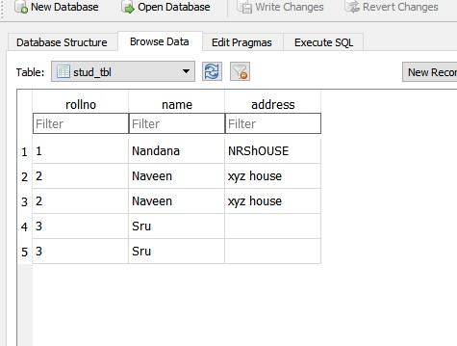

**DbRead**

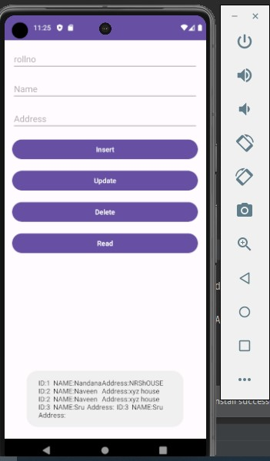

**DbDelete**

